Practical 1

Aim : Introduction to googe collab .

Code:

|  |
| --- |
| import pandas as pd  import matplotlib.pyplot as plt  import os csv_path=("/content/sample_data/california_housing_test.csv") v=pd.read_csv(csv_path)  print(v)  file_size  =os.path.getsize("/content/sample_data/california_housing_test.csv") print("File Size:",file_size,"bytes") csv_path=("/content/sample_data/california_housing_test.csv") df=pd.read_csv(csv_path)  print(df) |

df.plot(x='median_income', y='median_house_value',kind='bar') plt.show()

Output:

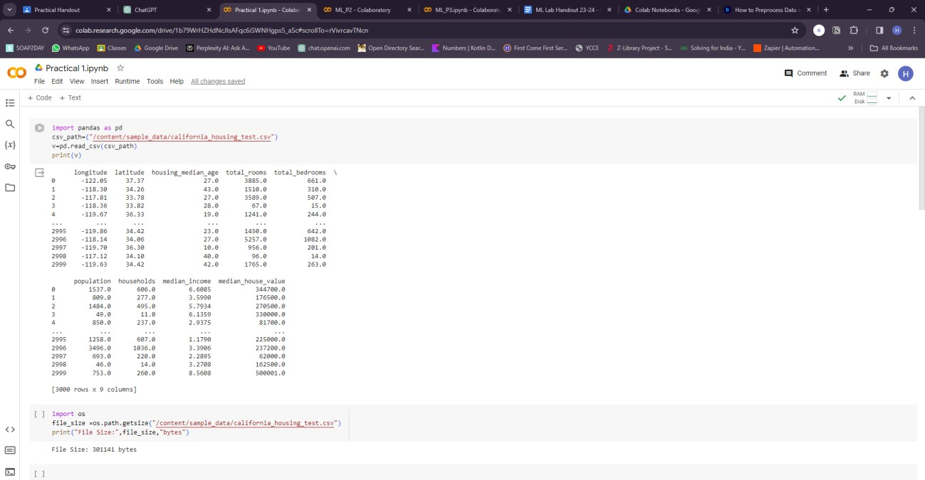

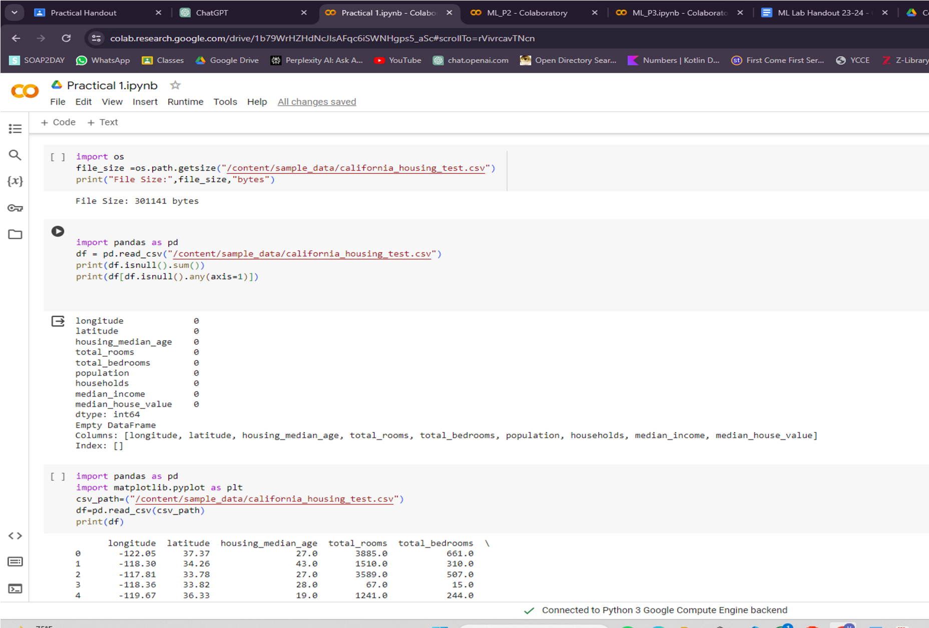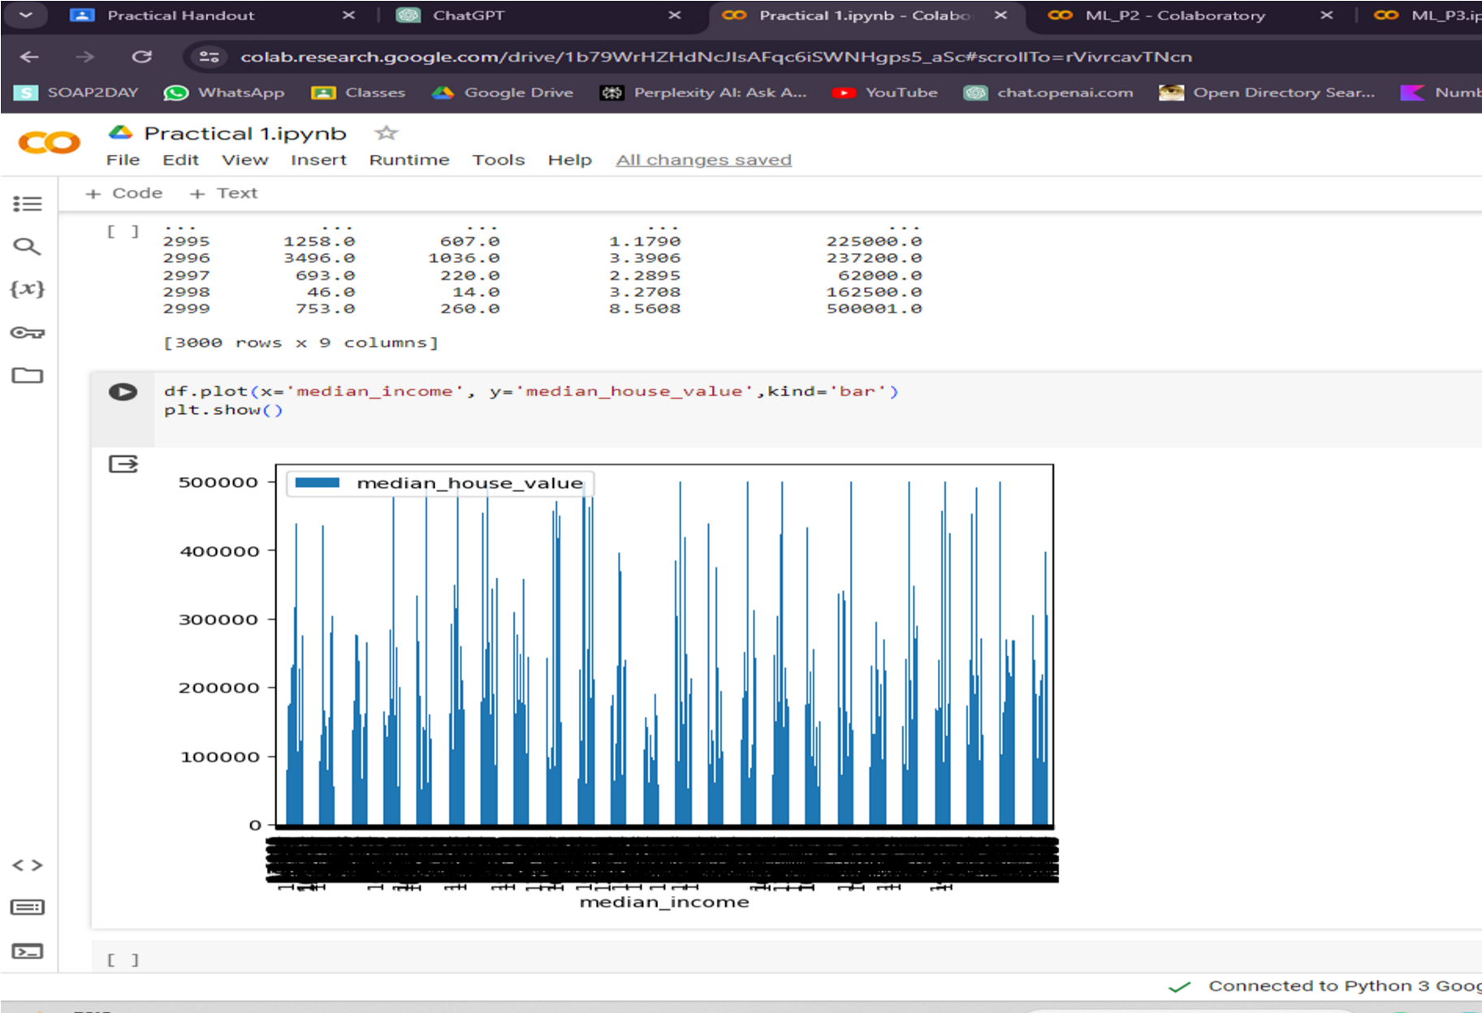

Practical 3

Aim : Classify the data into training , testing and validation.

|  |
| --- |
| #Let's get rid of some imports import pandas as pd import matplotlib.pyplot as plt import numpy as np from sklearn.datasets import load_iris    #Iris is available from the sklearn package iris iris = load_iris()  X, y = iris.data, iris.target  #Import Module  from sklearn.model_selection import train_test_split  X_train, X_test, y_train, y_test = train_test_split(X, y, train_size=0.8, test_size=0.2, random_state=42)    print("X_train: ", X_train) print("y_train: ", y_train) print("X_test: ", X_test) print("y_train: ", y_train)  plt.plot(X_test, y_test, 'o', color='black'); plt.plot(X_test, y_test,'o', color='black'); |

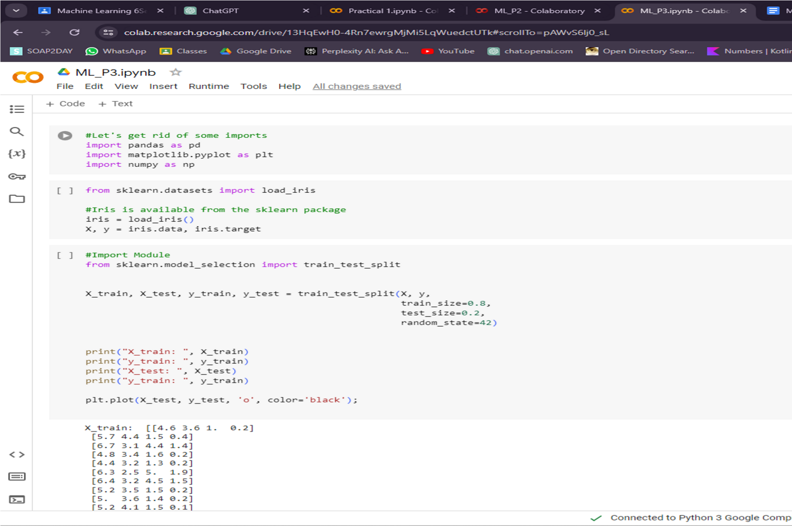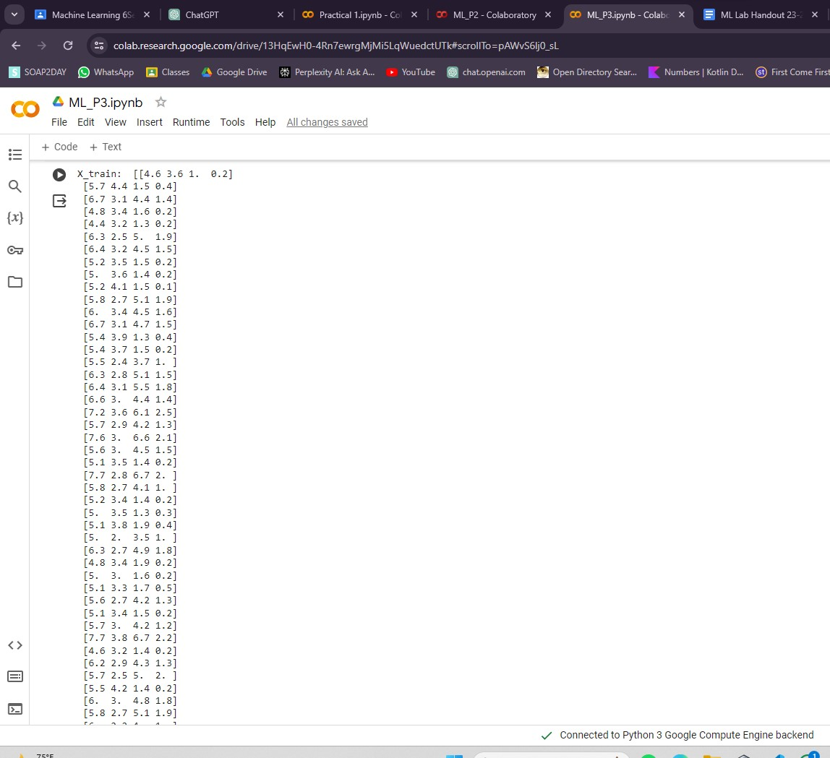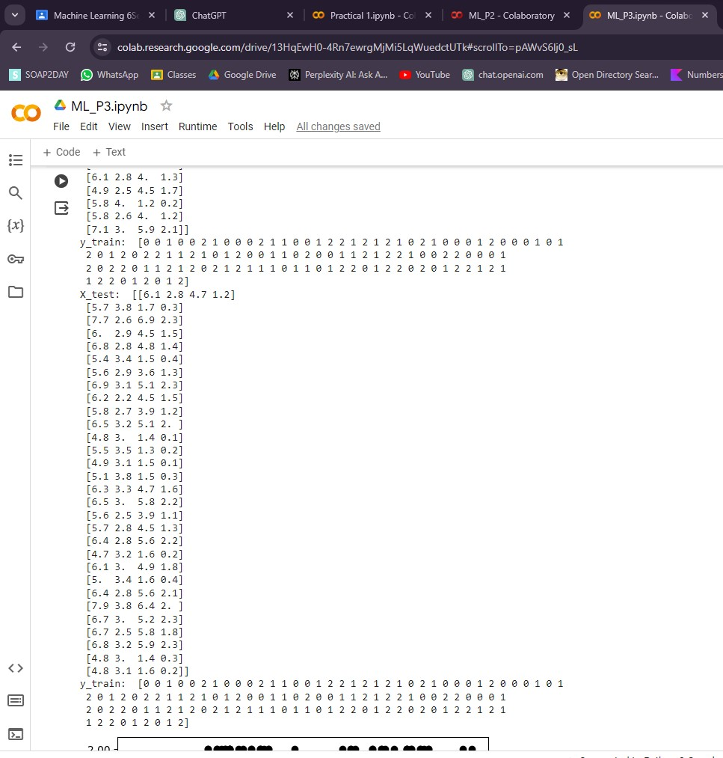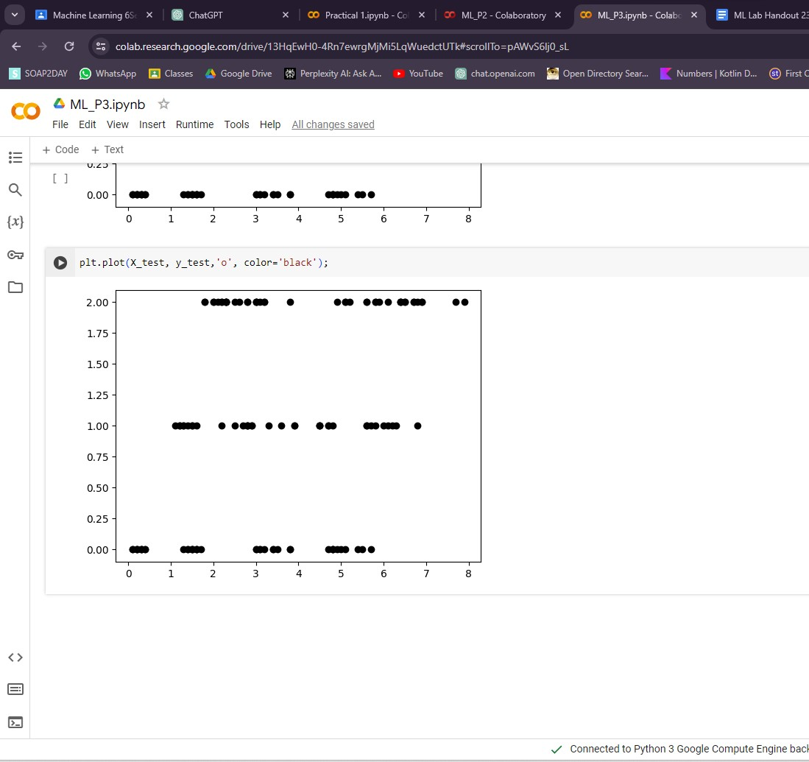

Practical 4

Aim : Program based on linear regression .

Code

|  |
| --- |
| import pandas as pd  import numpy as np  import matplotlib.pyplot as plt  from sklearn.model_selection import train_test_split from pandas.core.common import random_state  from sklearn.linear_model import LinearRegression  df_sal = pd.read_csv('/content/Salary_Data.csv') df_sal.head()      df_sal.describe()    plt.scatter(df_sal['YearsExperience'], df_sal['Salary'], color =  'lightcoral')  plt.title('Salary vs Experience') plt.xlabel('Years of Experience') plt.ylabel('Salary') plt.box(False)  plt.show()    X = df_sal.iloc[:, :1] |

|  |
| --- |
| y = df_sal.iloc[:, 1:]    X_train, X_test, y_train, y_test = train_test_split(X, y, test_size = 0.2 random_state = 0)  regressor = LinearRegression() regressor.fit(X_train, y_train)    X_pred_test = regressor.predict(X_test)  y_pred_train = regressor.predict(X_train)  plt.scatter(X_train, y_train, color = 'lightcoral')  plt.plot(X_train, y_pred_train, color = 'firebrick')  plt.title('Salary vs Experience (Training Set)')  plt.xlabel('Years of Experience')  plt.ylabel('Salary')  plt.legend(['X_train/Pred(y_test)', 'X_train/y_train'],  title = 'Sal/Exp' loc='best', facecolor='white')  plt.box(False) plt.show()  print(f'Coefficient: {regressor.coef_}') print(f'Intercept: {regressor.intercept_}') |

,

,

